Curriculum Vitae

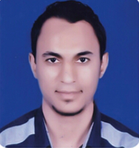
Name: Mahmoud Saleh Mahmoud Fahmy

Sex: Male

Date of Birth: May 8th, 1995

Place of Birth: Assiut, Egypt

Marital Status: Single

Contact Address: Department of Pharmaceutical Organic Chemistry, Faculty of Pharmacy, Assiut University, Assiut, Egypt

Cell Phone Number: +201159626245

E-mail: salehovic6@gmail.com, mahsalh8585@gmail.com,
Mahmoud@pharm.aun.edu.eg

Languages: fluent in Arabic and English

Education:
- Bachelor in Pharmacy, Faculty of Pharmacy, Assiut University, Assiut, Egypt, June 2018.
- Grade: Excellent with Honors.

Academic Positions
December - 2019 | Demonstrator at Department of pharmaceutical organic chemistry, Faculty of Pharmacy, Assiut University, Assiut, Egypt.

Computer skills:
- Microsoft office word
- Power-point
- Excel
- Access
- Internet

